PGSuper Architecture

Overview
The system architecture for PGSuper can be defined in three levels. First there is the Document View architecture inherited from MFC that provides the overall structure for the GUI. The Document class is not well suited to handle all of the engineering computations so this work is delegated to what is known as the Agent/Broker architecture. The Document class provided the “glue” between the engineering work and the Doc/View GUI. Finally, each “Agent” has its own internal architecture as needed.

MFC Doc/View Architecture
The MFC Doc/View architecture is explained well in the available literature. The figure below depicts how the Doc/View architecture provides the foundation for PGSuper’s GUI and how the document class bridges the Agent/Broker architecture.
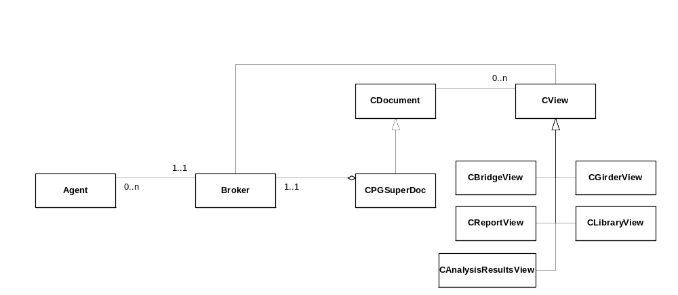

Agent/Broker Architecture
The goal of the Agent/Broker architecture is to allow “services” to be added and moved throughout the implementation without effecting existing code. Agents do all of the engineering work in PGSuper and the broker brokers the requests for information as the agents work. When an agent needs information, it simply goes to the broker and requests the interface from which the information can be obtained. The requesting agent has no idea where in the program that interface is implemented, it just knows to get the interface from the broker.

When an agent is on the receiving end of a request (a method on an interface that it implements is called), the agent does whatever work is necessary to fulfill that request. This might include requesting other interfaces from the broker, computing data, and/or looking up previously cached data.

Agents are registered with the PGSuper COM Component Category and are dynamically integrated into PGSuper at runtime. Refer to the documents “Creating a PGSuper Agent.doc” and “Adding an Interface to an Agent.doc” for more detailed information about how Agents interact with COM.

Agent Architectures
Each agent has its own individual architecture that supports the purpose of the agent. By design, all agents implement read-only interfaces except for the Project Agent. That is, all of the interfaces have “Get” methods except those implemented by the Project Agent. The purpose of the Project Agent is to manage the input data for a PGSuper project and thus it has read/write interfaces so the user interface classes can get the current input data, display it to the user, and set the new input data.

Much of the work done by the various agents is delegated to the services provided by the components of the Washington Bridge Foundation Libraries.

PGSuper Components

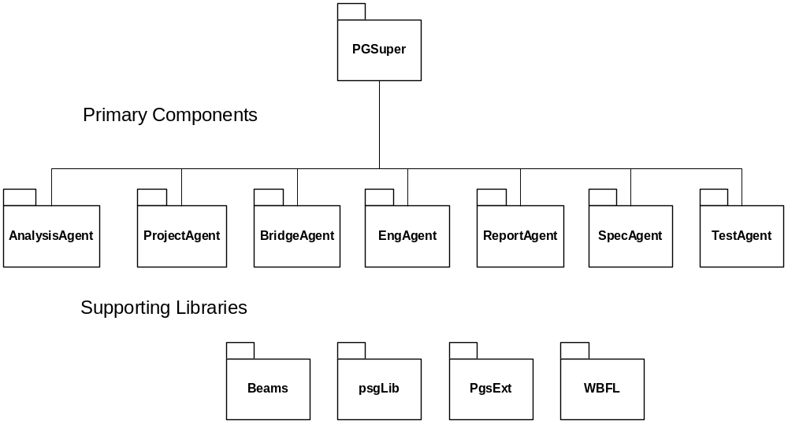
AnalysisAgent
Responsible for structural analysis

ProjectAgent
Responsible for managing input data (only agent with write-able interfaces)

BridgeAgent
Responsible for modeling of the bridge structure

EngAgent
Responsible for engineering computations

ReportAgent
Responsible for general reporting

SpecAgent
Responsible for implementing the LRFD specification

TestAgent
Responsible for NCHRP 12-50 style regression testing

WSDOTAgent
Responsible for WSDOT specific reporting and features

TxDOTAgent
Responsible for TxDOT specific reporting and features

Beams
Responsible for modeling beams of various cross sections and any computations that are a function of beam type

psgLib
Library of interface and data elements for the PGSuper Library

PgsExt
Library of common classes used throughout PGSuper

WBFL
Washington Bridge Foundation Libraries - Collection of supporting libraries
Washington Bridge Foundation Libraries (WBFL)
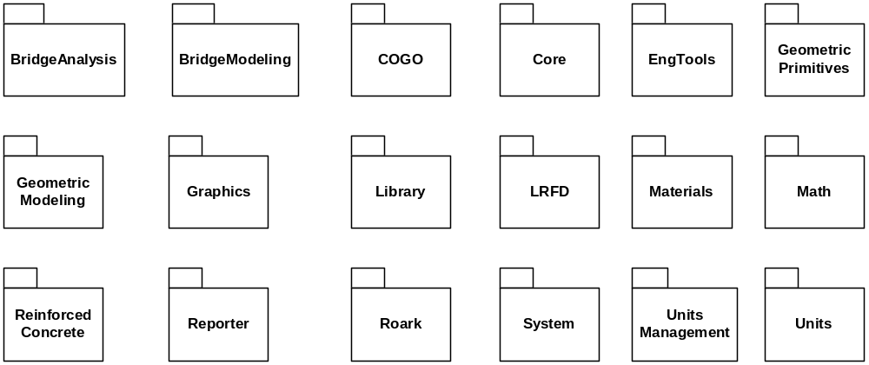

BridgeAnalysis
Provides services for structural analysis of bridges

BridgeModeling
Provides services for modeling highway bridge structures

COGO
Coordinate Geometry services

Core
Core components of the of the Agent/Broker architecture

EngTools
Basic engineering tools

Geometric Primitives
Modeling of geometric primitives such as points, lines, arc, and circles

Geometric Modeling
Modeling of structural properties of complex geometric shapes

Graphics
Utility library to assist with graphics

Library
A framework for adding "libraries" to applications

LRFD
Utility classes and functions for the LRFD specifications

Materials
Provides services for modeling structural materials (concrete, steel, etc)

Math
Utility library for mathematical operations (root finding)

MFCTools
Extensions to MFC

Reinforced Concrete
Services for analyzing biaxial bending of reinforced concrete structural members

Reporter
Services for generating reports

ReportManager
Services for managing report definitions, report creation, and viewing

ReportManagerAgent
Provides services of the ReportManager in the Agent/Broker architecture

Roark
Beam analysis using Roark's Formulas for Stress and Strain

System
System utility classes

Unit Management
Manages display units for UI and reporting

Units
Services for unit conversion

Main Sequence of PGSuper Execution
The following figure depicts the main sequence of executing PGSuper for a normal project.
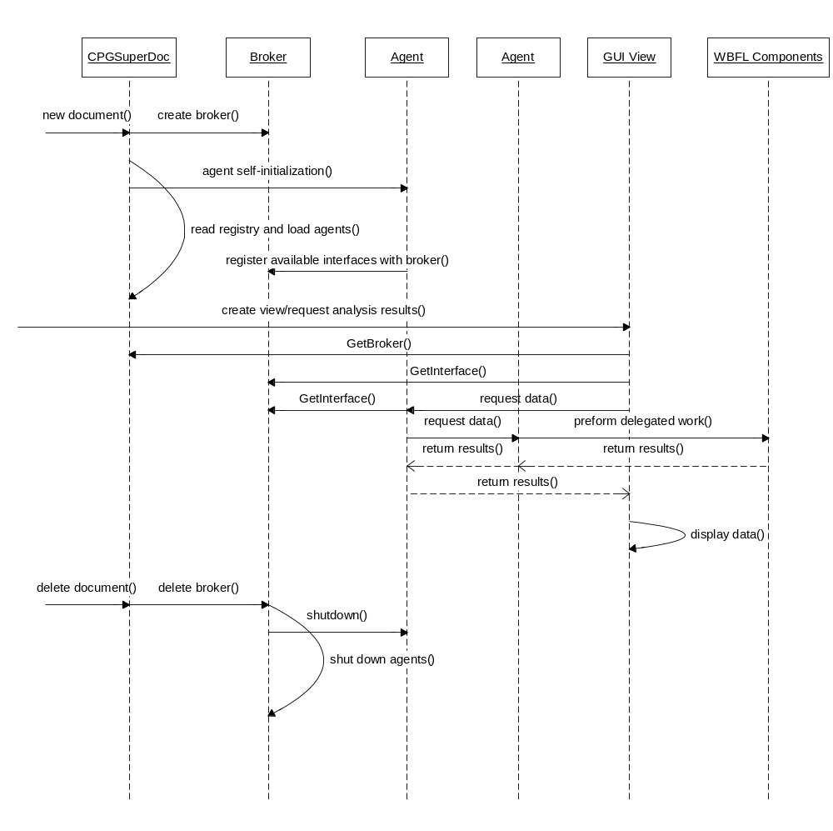
PGSuper users never have to request that an analysis is performed prior to requesting results. They simply make requests for results by opening reports and views. PGSuper knows to do whatever work is necessary to fulfill the request.

